**App**

**1. Define Users**

**2. Functionality for the App**

**Core Educational Features:**

* **Teaching Materials**: Videos, daily lessons, downloadable resources
* **Learning Modules**: Structured by topics (e.g. diagnostics, device usage)
* **Training Modules**: Simulated exams, AR-based device training
* **Quizzes & Reviews**: Embedded spaced repetition system for retention
* **Serious Games**: Gamified elements to reinforce practical skills
* **Language Options**: Multilingual accessibility
* **Progress Tracking**: Learning progress saved locally or synced
* **Device Learning Mode**: Mimics hands-on practice with Arclight tools
* **\*ALAN**

**Additional Features:**

* **Onboarding Process**: Tailored first-time user experience
* **Spaced Repetition Reminders**: For long-term knowledge retention
* **Interactive UI**: Drag, touch-based elements to mimic device handling

**3. Technical Parts**

**Platform**

* Mobile-first; potential deployment as:
  + **Progressive Web App (PWA)** – for offline support
  + **Native APK** – where internet access is limited
* **Offline Capability**:
  + Caching teaching materials and progress
  + Local video playback

**AR / Game Tech:**

* AR-enabled components for realistic diagnostic training
* Embedded Unity WebGL or native Unity builds for simulations
* Serious games for applied learning

**Analytics and Testing Tools:**

* SUS (System Usability Scale)
* IMMS (Instructional Materials Motivation Survey)
* HARUS (AR-specific usability)

**4. User Journey**

**Learning Pathway:**

1. **Installation**: Via app store, APK sideload, or PWA link
2. **Onboarding**: Guided walkthrough of app features
3. **Learning Module**: Choose topics and begin lessons (text + video)
4. **Interactive Training**: AR simulations, device mimicry, hands-on tasks
5. **Quiz**: Immediate and spaced-repetition-based questions
6. **Review**: Weekly reminders, scenario-based recaps
7. **Long-Term Retention**: Final spaced review and performance tracking

**App Content Details**

**1. Onboarding**

**Features**

- Language Selection

- Device Compatibility Check

- User Type Selection (Student/Clinician etc.) > lots of user pools

- Intro Tutorial (Video or Guided Tour)

**Content Focus**

- Welcome & App Purpose

- Navigation Walkthrough

- Link to Arclight Project Intro Video

**2. Learning Modules**

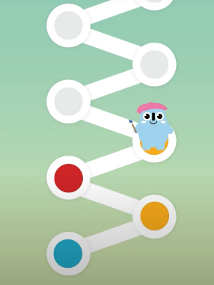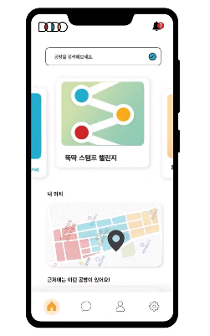

Learning tracking examples

**Features**

- Interactive Lessons

- Daily Learning Cards

- Videos

- Tracks Learning

**Content Focus**

- Eyes Modules (and Ear&Skin)

- Primary Eye Care Procedures

- Otoscopy, Visual Acuity, Fundoscopy

- History Taking (Eyes/Ears)

- Red Eye, Proptosis, Ptosis

**3. Diagnostic Training**

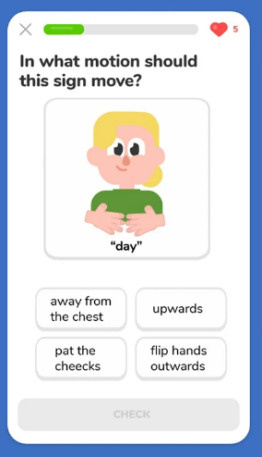

'What to ask patients' example

**Features**

- Case Study (Including ‘what to ask patients’)

- 3D Device Handling (AR/Serious Games)

- Quizzes per Topic

**Content Focus** Difference sections. Some. Need to tlk through more. Depends on the professionalism.

- Direct/Indirect Ophthalmoscopy

- Retinopathy (ROP, DR, CM)

- Eye Movement, Visual Fields > more sophisticated. Difference sections.

- Ocular Trauma Score

- Near & Distance Vision

- William’s Apps

**4. Case-Based Scenarios**

**Features**

- ‘Guess What I Am’ Game

- Real-life Case Simulations

- Weekly Quiz and Review

- Spaced Repetition

**Content Focus**

- Vision Loss, Glaucoma Risk

- Presbyopia, Childhood Screening

- Red Desaturation, Cranial Nerve Exam

**5. Review & Assessment**

**Features**

- Test Yourself Section

- Progress Tracker

- Final Knowledge Check

**Content Focus**

- Comprehensive Review

- Retest of All Major Tools

- Workshop Delivery Mode

**6. Community & Links**

**Features**

- Mentorship Forum

- Resource Library

- Offline Help Guide

- My Account

**Content Focus**

- Links to Orbis, RCO, AAPOS, WHO

- CVI Scotland, SightSIM

- RAAB Tools and Community Health Info

**Zambia Minimal Viable Product(MVP) Testing Plan**

**Purpose**

The goal of this MVP test is to determine whether the app runs effectively in African environments, where connectivity and device availability may vary. This pilot will help us evaluate technical performance and user preferences before wider deployment.

**MVP – Priorities**

* Demonstrate key diagnostic techniques effectively.
* Ensure text-based quiz functions operate smoothly.
* Confirm that notification features work correctly in offline mode.
* Verify that touch and drag interactions perform reliably on various devices.
* Create and compare both a simple HTML version and an APK version of the app. (Although Jamie mentioned the format matters depending on what we want to do with the app, I thought it would still be worth finding out with works better when we have chance.)
* Optimise both versions for performance prior to field testing.

**Test Versions**

* **HTML version**: Direct Ophthalmoscopy module I created, with embedded videos and simplified navigation.
* **APK version**: Pupil Exam App, updated with a dashboard and buttons to access additional modules from within the app.

**Survey Topics**

* **Device Information**: Type of phone and software used. (Previous data suggests ~84% Android usage, 55% using 3G and 22% 4G.)
* **Performance**:
  + Was the download/installation smooth?
  + Did the app load and run without issues, or were there delays?
* **Platform Preference**:
  + Would users prefer using the app on mobile or desktop?
  + (Existing data shows ~80% mobile usage, ~20% desktop, and minimal tablet usage in Africa.)
  + Clarify whether desktop/mirroring features would mainly be used in group or lecture settings, or if learners would engage with the app independently in their own time.